**West Loop Mart**

I am going to develop an online web application for the West Loop Mart which is a startup restaurant that has hams and Vienna beef hot dogs, Italian beef, cheesy beef. This might be a kind of subway features. I will be using PHP for developing this web application and MySQL(PHP- Myadmin) as back end.

Purpose of this project is to globalize the West Loop Mart as it is the startup restaurant with some good and affordable food.

**Important features focused to be implemented are:**

-> Website will be featured with all the verities of subs rendering dynamically upon user request.

->Customers can have online delivery upon requested.

->Implementing a feature that would help user to be connected to all the social networking sites.

->Implementing payment method with the help of PayPal procedure.

->Admin functionalities: Admin can have functionalities to add or delete the new or existing products from the website by which the website will be easy to maintain in the later stages.

->Implementing Google maps features to locate the restaurant.

->Implementing a good navigation process.

->Implementing a better visually appealing, polished and professional website.

West Loop Mart core product is the submarine sandwich (or "sub"). In addition to these, the chain also sells wraps, salad, and baked goods (including cookies and muffins).

The sub which they offers are following:

1) Turkey Ham

2) Turkey

3) Veggie sub

4) Smoked Turkey

5) Honey Turkey

6) Ham & Turkey

7) Roast Beef

8) Corn Beef

9) Roast Beef & Corn Beef (combo)

10) Corn Beef on Rye

**Italian Beef**

1) Italian Beef

2) Cheezy Beef

West Loop Mart’s best-selling subs are served with lettuce, tomato, onion, mayonnaise, mustard, cheese and a choice of hot pepper or sweet pepper.

Below are the following pictures taken from the mart.

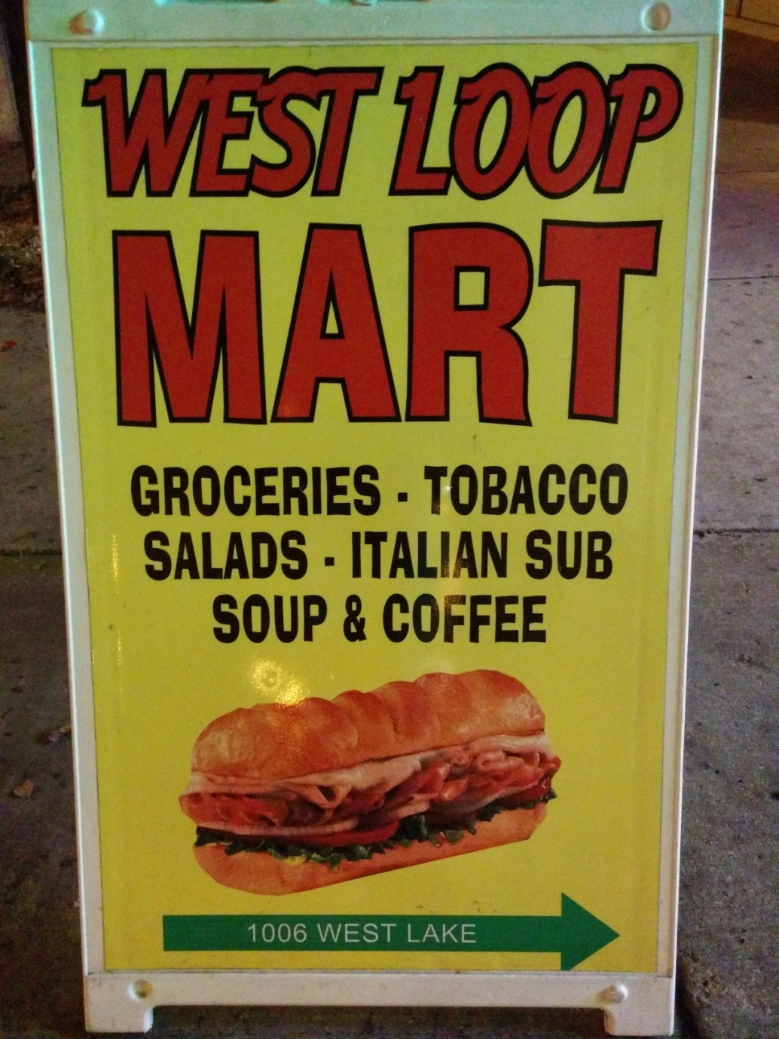

Here are the menu items which they offer.

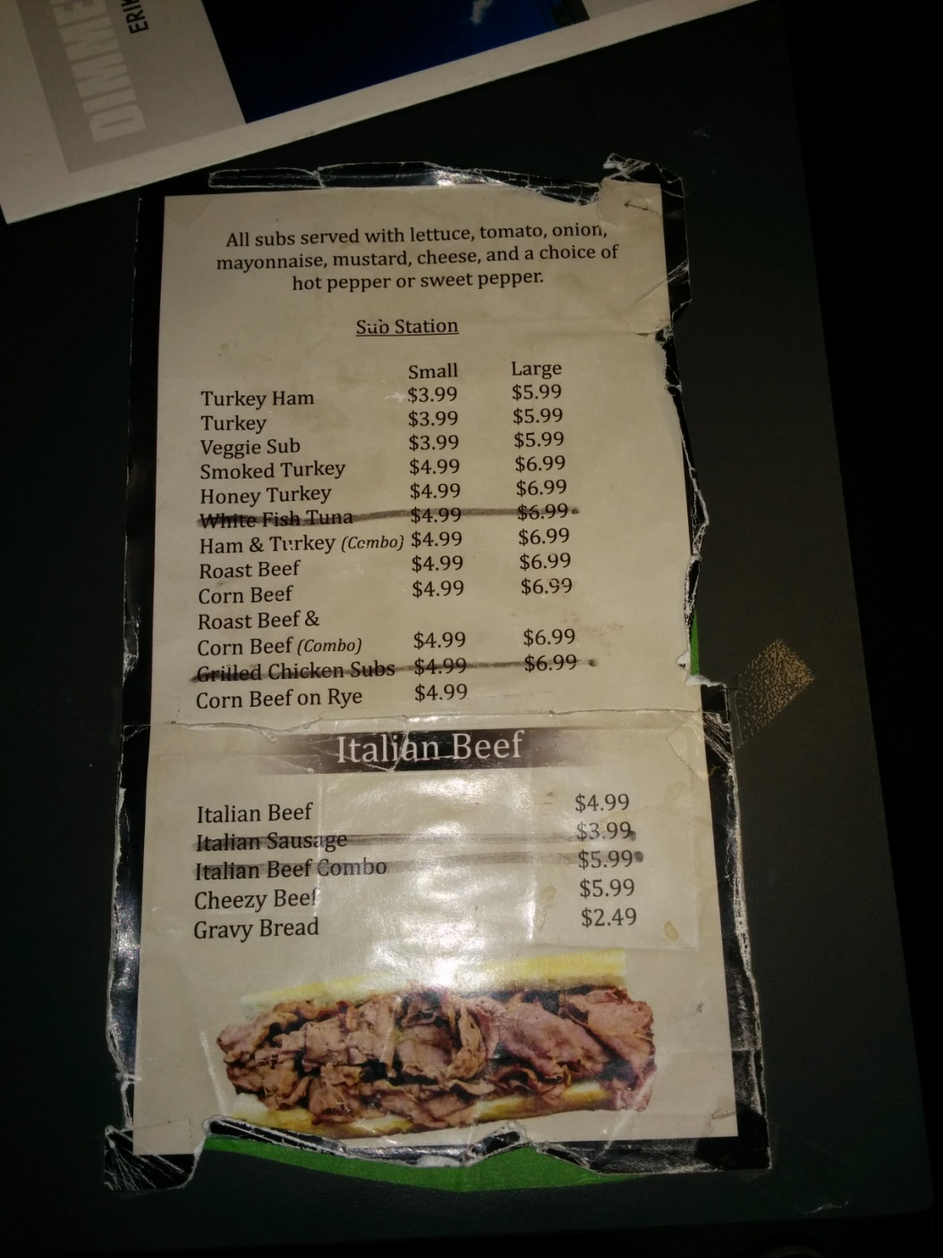

**Main Purpose**:

I am willing to do this project as a token of respect to my uncle who is the owner of west loop mart, because I want to make sure my time and Knowledge is utilized and my uncle also saves money ☺ .